Sponsored by: Greensville/Emporia Department of Social Service
Project Learning Tree®
Environmental Experiences for Early Childhood
This training will equips early childhood educators with hands-on activities that help them weave environmental education into their daily routine.
Saturday, December 10, 2016
9 AM-12 Noon

Southern VA Regional Medical Center-Classroom
727 North Main Street
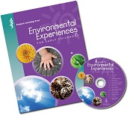
Emporia, Va 23847

You will receive an activity guide and CD and additional materials to enhance classroom implementation of training

To register
Leave the following information: Name, phone # e-mail and the program in which you work.
e-mail-gmorris@arls.org (preferred) 434-660-9243

